- Getting Started with
- 3ComCourier I-modem

3Com is committed to providing you with quality products; we’re sure you’ll find the 3ComCourier
I-modem to be:
- Reliable
- Easy
- Configurable
- Cost-effective
- Fun!

- Internal I-modem
- Required hardware
• IBM-compatible computer with a free interface card slot
• An ISDN Basic Rate Interface line
• Communications software
- An NT-1 and Power Supply (I-modem S/T only)

- Required Software
- Make Sure You Have the Correct INF File!

MDMUSRIM.INF | Supports DTE rates up to 115.2 kbps
CR230K.INF | Supports 230.4 kbps (if used in conjunction with a serial card that supports 230.4 kbps)

To configure your I-modem, please refer to your 3Com I-modem Configuration Manager software or the Command Reference Guide.

Step 1: Configuring with Jumpers
Your I-modem is configured for Plug and Play, allowing Windows 95 to automatically configure itself to work with the I-modem.
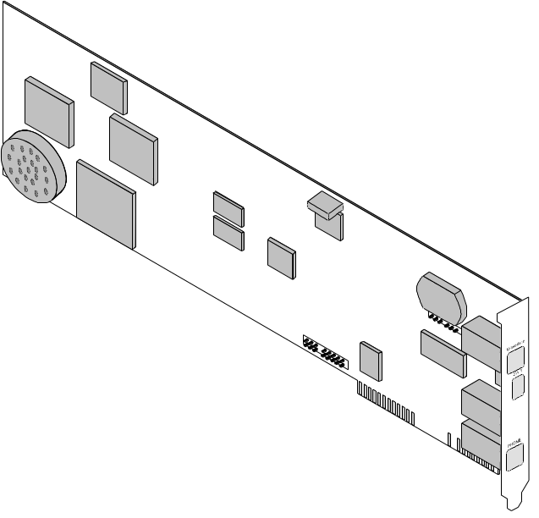
Jumpers

Default Jumper Settings
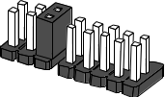

Correct Jumper Settings
Use the tables below to set your I-modem to specific COM port and IRQ settings.

Setting Jumpers for a Specific COM Port or IRQ

To set your modem to | To set the COM port jumpers to
COM 1 | 
COM 2 | 
COM 3 | 
COM 4 | 
Plug and Play | 

Setting Jumpers for a Specific IRQ

To set your modem to | To set the IRQ jumpers to
IRQ 2 | 
IRQ 3 | 
IRQ 4 | 
IRQ 5 | 
IRQ 7 | 

Notes:
- The S/T version has an additional set of jumpers to control termination.
- For most configurations, default settings will work. However, if your environment has multiple ISDN devices or you are using an NT-1, see the
I-modem Command Reference manual.

Windows 95 Users
If you are using Window 95, you do not need to change the Plug and Play jumper settings, because Windows 95 automatically detects and configures your I-modem.

Other IBM-PC Compatible Operating Systems
If you are using an IBM-PC compatible operating system, you may need to change the jumper settings to a COM port or IRQ setting that is not already used by your system.
For information about setting jumpers for different COM ports and IRQ settings, see Chapter 12, Configuring Your Courier With DIP Switches and Jumpers.

Step 2: Configuring with DIP Switches
You will probably not need to change the DIP switch settings, but review this section to be sure.
The DIP (Dual Inline Package) switches are located on the bracket of the I-modem.
DIP switches

 | OFF ON
No effect  No effect  Ignore AT commands  Load &F0 template settings on power-on or reset | 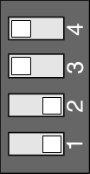 | No effect  No effect  Act on AT commands  Load NVRAM settings at power-on or reset

If you change the DIP switch settings while the
I-modem is on, you can avoid powering your computer off to make the new settings take effect. Just send the I-modem the ATZ or the ATZ! command.

Step Three: Inserting the Modem
Note: The illustrations in this section may not match the appearance of your computer. For more detail, refer to your computer’s user manual.
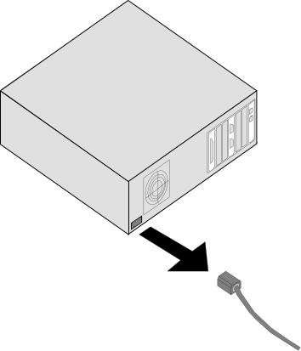
1 Turn off the computer’s power and unplug the computer’s power cord. Ground yourself.
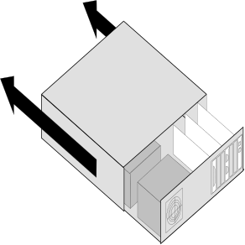
2 Remove the screws that hold on the computer’s cover and slide the cover off.
3 Find an empty expansion slot that provides enough room to install your Courier.
4 Remove the screw that holds on the slot cover and remove the slot cover. Save the screw!
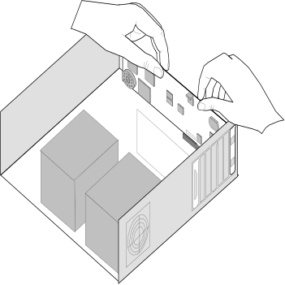
5 Insert your Courier into the slot and press down on the top edge of your Courier until it is seated firmly.
6 Using the screw you saved in Step 4, secure your Courier in your computer.
7 Replace the cover of your computer and tighten the screws.
You are now ready to connect the cables.

Step Four: Connecting the Cables

I-modems with Integrated NT-1 Model U
1 Connect one end of the U-interface cable to the ISDN BRI jack and the other end to the I-modem.
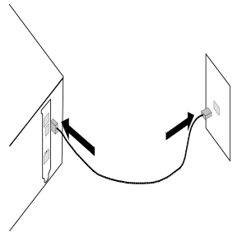
2 If your I-modem has an Analog Device port, connect an analog device, such as a standard telephone, now.
Be aware that the internal I-modem does not provide ringing voltage, which may prevent normal operation of devices that auto answer (such as fax or answering machines).

I-modem Model S/T
1 Connect one end of the S/T-interface cable to an S/T port on your NT-1 and the other end to the I-modem.
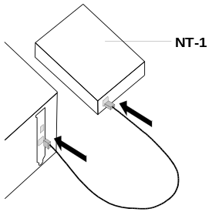
2 Install the NT-1 according to the steps listed in its documentation.

External I-modem
Required hardware

- Computer or terminal with a serial port (16650 UART recommended)
- ISDN Basic Rate Interface (BRI) line
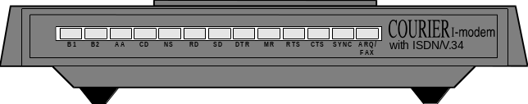
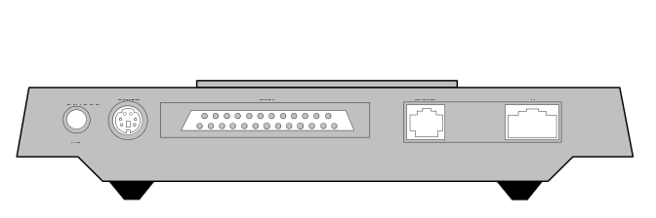

Step One: Connecting the Serial Cable
1 Look at the back of your computer for a port.

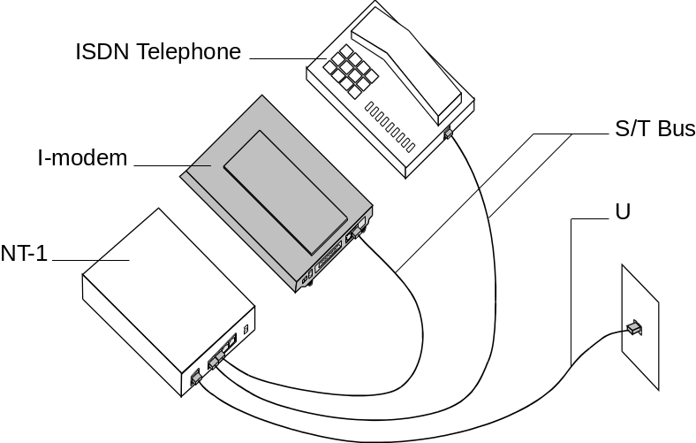
This is a typical Model S/T configuration, which requires an external NT-1 unit to connect to the ISDN wall jack. The I-modem Model U configuration is similar, but does not require an external NT-1. Instead, the I-modem Model U has an internal NT-1 and connects directly to the ISDN wall jack.

Step Two: Connecting the ISDN Cable
1 After you have selected the correct cable, connect the male DB-25 end of your serial cable to your Courier I-modem and the other end to a serial port on your computer.
2 Connect one end of the phone cable to the wall jack and the other end to your Courier I-modem port labeled U.
3 If you have Model U and a telephone that you’d like to connect to your Courier I-modem, plug its cable into your Courier port labeled PHONE.
4 Plug one end of the power adapter into your Courier I-modem and the other end to a standard AC power outlet.
5 Switch your computer and modem power on.
You are now ready to configure your Courier
I-modem.

Testing the Installation
To test your Courier, use any communications software package, such as Windows Terminal, HyperTerminal, ProComm Plus, or RapidComm. HyperTerminal is used as an example.
1 Run HyperTerminal.
2 Enter the name of your connection in Name and click OK.
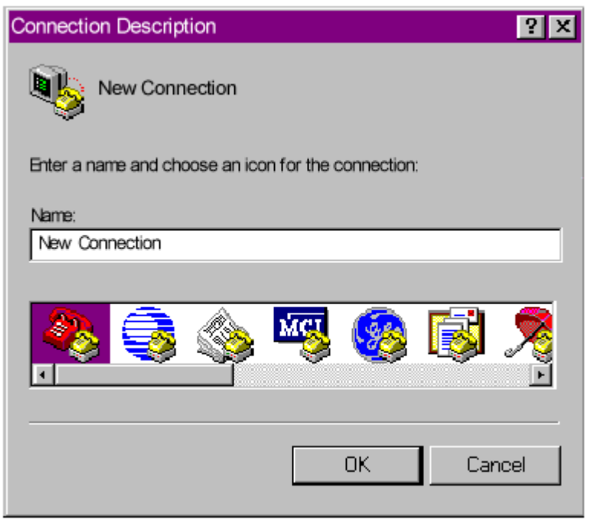
3 Enter the phone number you want to dial in Phone number and click OK. If you only want to test your modem, you may enter any number.
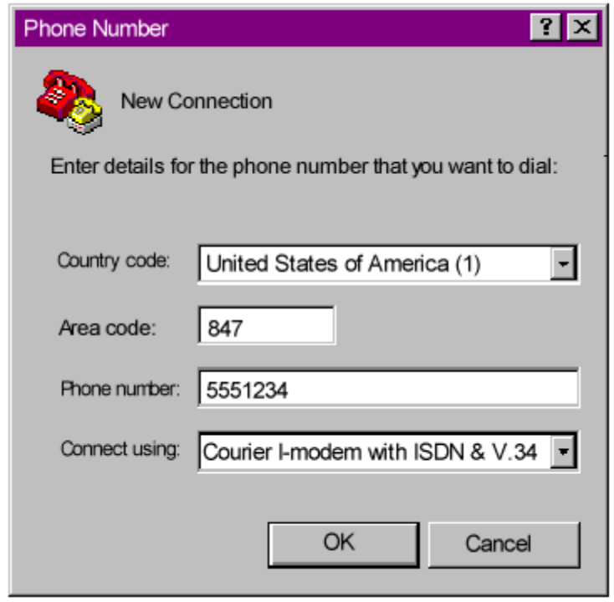

4 Change any properties and:

To… | Click…
Dial a number | Dial
Test without dialing a number | Cancel

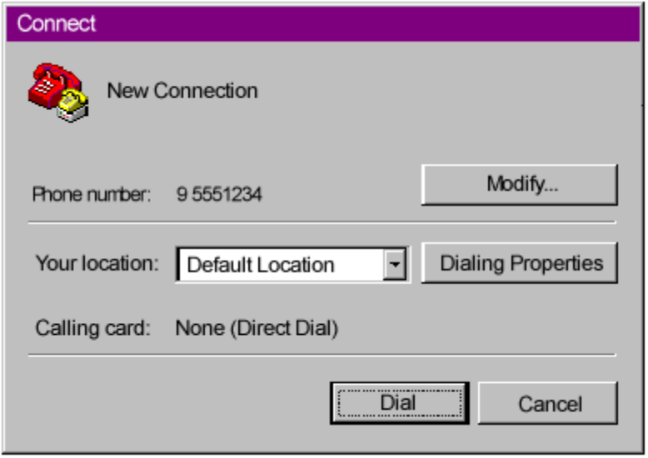

5 When the HyperTerminal terminal window appears, enter AT and hit <enter>. If your modem is connected and configured properly, you will see “OK” on the terminal screen.
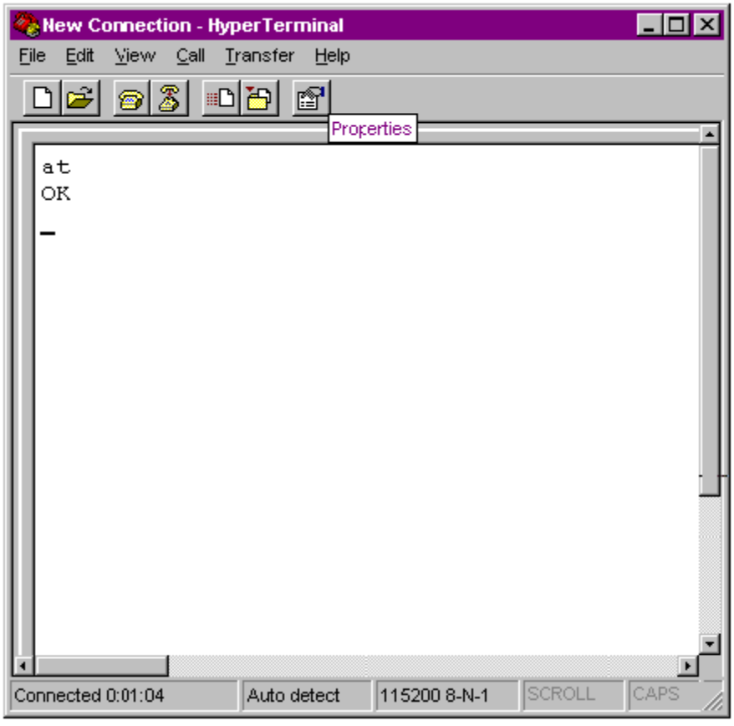
You are now ready to configure your Courier modem.

